Premium Payment & Policy Issuance USER STORY
- Description
As a customer purchasing a life insurance policy
I want to make the premium payment through a secure online payment gateway
So that my payment is processed successfully and my policy document is automatically generated and shared with me.

- Acceptance Criteria
ID | Acceptance Criteria
AC1 | The system should allow customers to pay the premium through integrated payment gateways (UPI, card, net banking).
AC2 | The system should record successful payment transactions in the system with transaction details.
AC3 | If the payment fails, the system should display an error message and allow the customer to retry the payment.
AC4 | Once the payment is successful, the system should generate a unique policy number.
AC5 | The system should automatically generate the policy document in PDF format.
AC6 | The generated policy document should include customer details, policy details, nominee details, and policy terms.
AC7 | The system should store the generated policy document in the system.
AC8 | The system should send the policy document to the customer via email.
AC9 | The system should notify the customer via SMS confirming policy issuance.
AC10 | The policy status should be updated to Active after successful payment and policy generation.

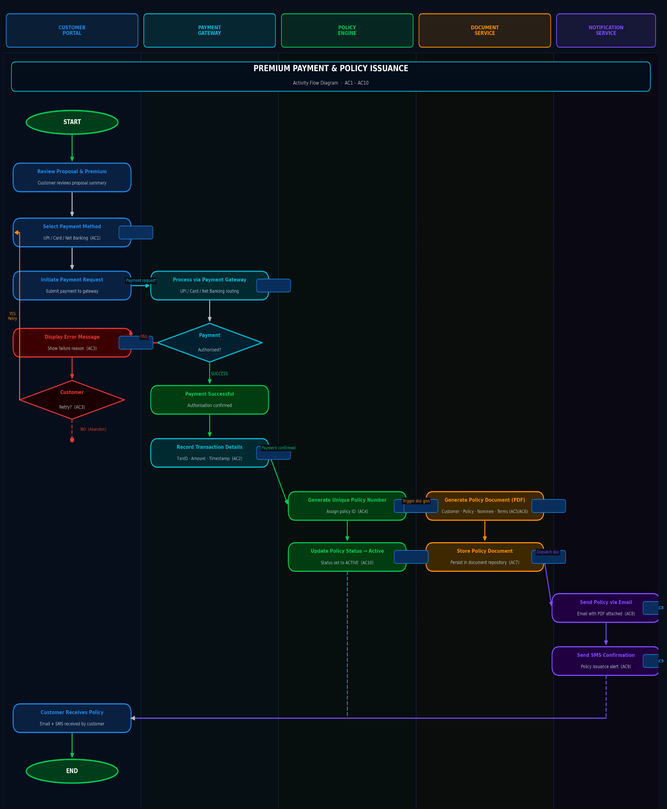
- Activity Flow Diagram

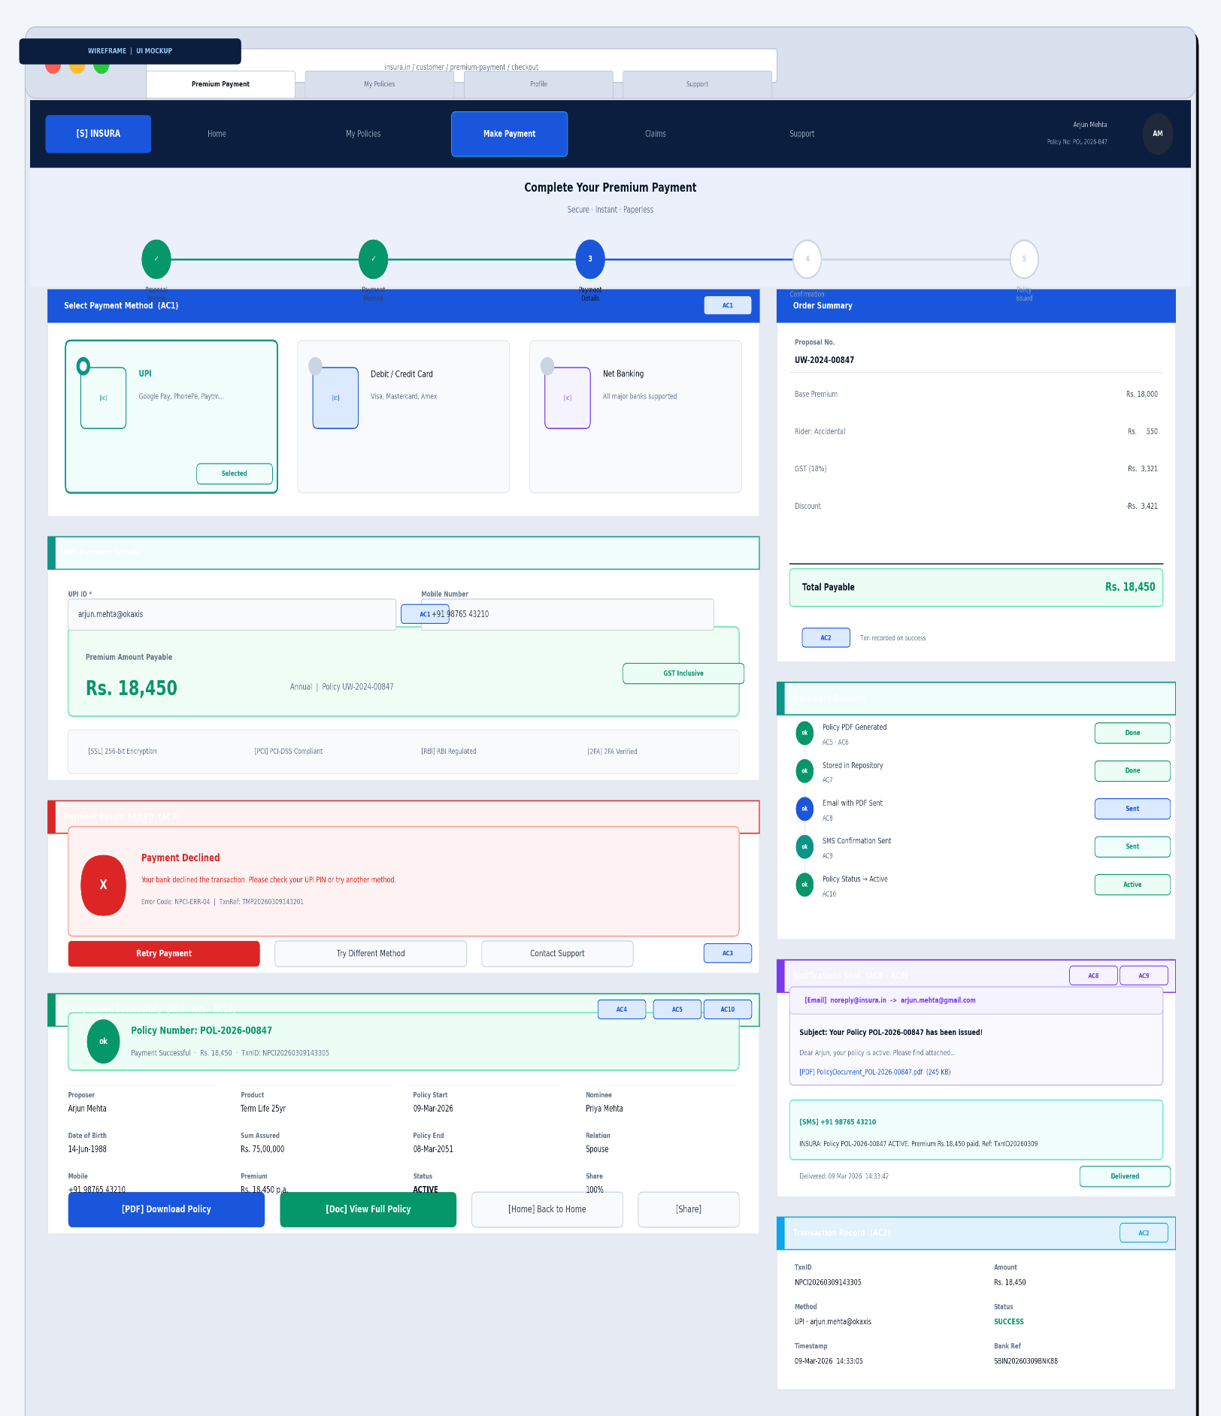
- Wireframe

